1 Oracle Cloud Infrastructure Security Architecture / version 2.0
Copyright © 2021, Oracle and/or its affiliates / Public



Vodafone UK
Synthetic Data Generation and Data Mining Pilot



Statement of Work
This document outlines the scope of Vodafone’s Synthetic Data Generation and Data Mining Project, detailing the proposed solution and associated deliverables. It highlights how Vodafone can leverage Oracle’s AI capabilities within Oracle Cloud Infrastructure (OCI) and the 23AI platform to address current challenges and optimize operations.
By utilizing Oracle's Generative AI services, Select AI capabilities, and advanced GPU resources, this transformation aims to enable efficient, scalable, and intuitive data interaction for Vodafone. The project will streamline manual data retrieval processes, improve productivity, and align seamlessly with Vodafone’s strategic objectives to innovate and optimize operational efficiency.

Safe Harbor
The following is intended to outline our general product direction. It is intended for information purposes only and may not be incorporated into any contract. It is not a commitment to deliver any material, code, or functionality, and should not be relied upon in making purchasing decisions. The development, release, timing, and pricing of any features or functionality described for Oracle’s products may change and remains at the sole discretion of Oracle Corporation.

Table of Contents
Statement of Work 2
Safe Harbor 2
1. Executive Summary and Overview 4
1.1 Business Summary 4
1.2 Business Challenge 4
1.2 Return on Investment 4
1.2.1 Scenario Analysis 5
1.2.2 Enterprise-Wide Impact 5
1.2.3 Value in Terms of Productivity and Costs 5
2. Proposed Solution 5
2.1 Database Migration to 23AI 5
2.2 Generative AI Services on Oracle Cloud Infrastructure (OCI) 5
2.3 Intuitive Front-End Interface with Apex 6
2.4 Key Benefits 6
2.5 Bill of Material 7
3. Solution Components 8
3.1 Autonomous Database Select AI 8
3.2 Generative ai and LLM Models 8
3.3 Low Code Apex UI 8
4. High level Architecture 9
5. Conclusion 10
6. References 10

1. Executive Summary and Overview

1.1 Business Summary

This proposal presents a comprehensive AI-driven solution tailored to address Vodafone’s operational challenges and strategic goals. By integrating Oracle’s advanced AI technologies within Oracle Cloud Infrastructure (OCI) and the 23AI platform, this solution aims to revolutionize data mining and synthetic data generation processes. The integration of Select AI capabilities and Generative AI services will empower Vodafone to automate repetitive tasks, enhance data accessibility, and streamline workflows.
The proposed solution includes a user-friendly Apex-based front-end interface, ensuring seamless interaction for testing agents while significantly improving productivity and efficiency. By leveraging Oracle’s Select AI and Generative AI capabilities, Vodafone will experience enhanced performance, scalability, and precision in handling high-volume test scenarios.
Adopting this solution will position Vodafone to stay at the forefront of innovation, ensuring operational excellence and alignment with its long-term digital transformation and growth objectives. The proposal also provides an overview of the solution’s key features and benefits, along with a roadmap for implementation to achieve maximum business value.

1.2 Business Challenge
Currently, testing agents at Vodafone manually simulate user experiences by accessing proxy URLs, such as Vodafone’s sales URL, to retrieve customer-specific details (e.g., User IDs, Customer Details, and Purchase History). This manual process is:
- Time-consuming and repetitive.
- Inadequate for handling the high volume of test scenarios (thousands regularly).
An automated solution is needed to enhance productivity and accuracy in processing and retrieving data for test scenarios.

1.2 Return on Investment
The proposed AI-driven solution delivers significant time savings and productivity gains for Vodafone's testing agents, directly translating into measurable operational efficiency.
Currently, each testing agent spends approximately 5 minutes retrieving data manually from the database and an additional 5-10 minutes verifying the information for each scenario test. This means agents dedicate an average of 10-15 minutes per scenario to these repetitive tasks.
With the implementation of Select AI and Generative AI, these processes will be automated and streamlined, allowing agents to retrieve and verify the required data almost instantaneously through natural language prompts. By reducing the time required for each scenario to just a few seconds, the solution dramatically improves efficiency.

1.2.1 Scenario Analysis
- Each agent performs approximately 20 scenario tests per day, spending 200-300 minutes daily on manual data retrieval and verification.
- With the AI solution, this effort is reduced to an estimated 10-20 minutes daily, saving 190-280 minutes per agent per day.

1.2.2 Enterprise-Wide Impact
Vodafone employs 100 agents for testing, translating to a collective daily time savings of:
- 19,000–28,000 minutes (or 316–466 hours) per day.
Over a month (assuming 20 working days), this equates to:
- 6,320–9,320 hours of saved productivity.

1.2.3 Value in Terms of Productivity and Costs
By enabling agents to focus on higher-value tasks and reducing downtime, this solution not only improves operational efficiency but also reduces the hidden costs associated with manual inefficiencies. The enhanced productivity could lead to faster project cycles, improved testing quality, and more accurate outputs—all contributing to Vodafone’s bottom line and innovation objectives.
This solution is a transformative investment that ensures sustained time and cost savings while empowering agents to deliver exceptional performance.

2. Proposed Solution
At Oracle, we recognize that each organization has unique requirements for adopting and integrating AI technologies. For Vodafone, we propose a highly customized solution that leverages the full potential of Oracle Cloud Infrastructure (OCI), Select AI capabilities, and Generative AI services to address operational challenges and streamline workflows. This solution is specifically designed to optimize data retrieval and synthetic data generation processes, ensuring efficiency, scalability, and ease of use.
Our solution is built around three core components:

2.1 Database Migration to 23AI
We will migrate Vodafone’s relevant data into the 23AI platform, enabling advanced conversational AI features powered by Select AI. This will allow testing agents to interact with the database using natural language prompts, eliminating the need for complex manual queries and enabling faster data retrieval.

2.2 Generative AI Services on Oracle Cloud Infrastructure (OCI)
Generative AI capabilities in OCI will be deployed to enhance the system’s natural language understanding and data processing abilities. These services will automate repetitive and time-consuming tasks, provide predictive insights, and ensure that data mining processes are efficient and intuitive for all users.

2.3 Intuitive Front-End Interface with Apex
An Apex-based front-end interface will be developed as the primary tool for agents to interact with the AI-powered backend. This user-friendly platform will simplify data extraction, automate query responses, and provide a seamless experience for agents handling thousands of test scenarios.
By implementing this solution, Vodafone will benefit from:
- Automated workflows that reduce manual intervention.
- Enhanced scalability to handle high volumes of test scenarios.
- Real-time insights through conversational AI interfaces.
- Improved productivity and usability with an intuitive interface tailored to testing agents’ needs.

2.4 Key Benefits

The key benefits of this solution include significant automation of repetitive tasks, which will free up testing agents to focus on more strategic activities. By leveraging Oracle’s AI technologies, Vodafone will enhance efficiency and scalability in data retrieval, handling thousands of test scenarios with ease. The intuitive front-end interface will streamline workflows, improve productivity, and provide agents with real-time, accurate insights through natural language interactions. Ultimately, this solution will reduce manual effort, increase operational efficiency, and enable Vodafone to stay at the forefront of innovation, all while aligning with its long-term strategic goals.

- Automation of Repetitive Tasks: Eliminate manual data retrieval processes, allowing agents to focus on higher-value tasks.
- Enhanced Efficiency: Faster and more accurate data retrieval for high-volume test scenarios.
- User-Friendly Interface: Intuitive front-end that reduces the learning curve and improves productivity.
- Scalability: Scalable solution capable of handling thousands of test scenarios.
- AI-Driven Insights: Use of advanced AI models to derive meaningful insights from data.

2.5 Bill of Material
Detailed Excel sheet will be shared as a separate document.
A Quick note on Object Storge Cost – this cost is temporary cost only as it will be used as Staging area for DB migration.

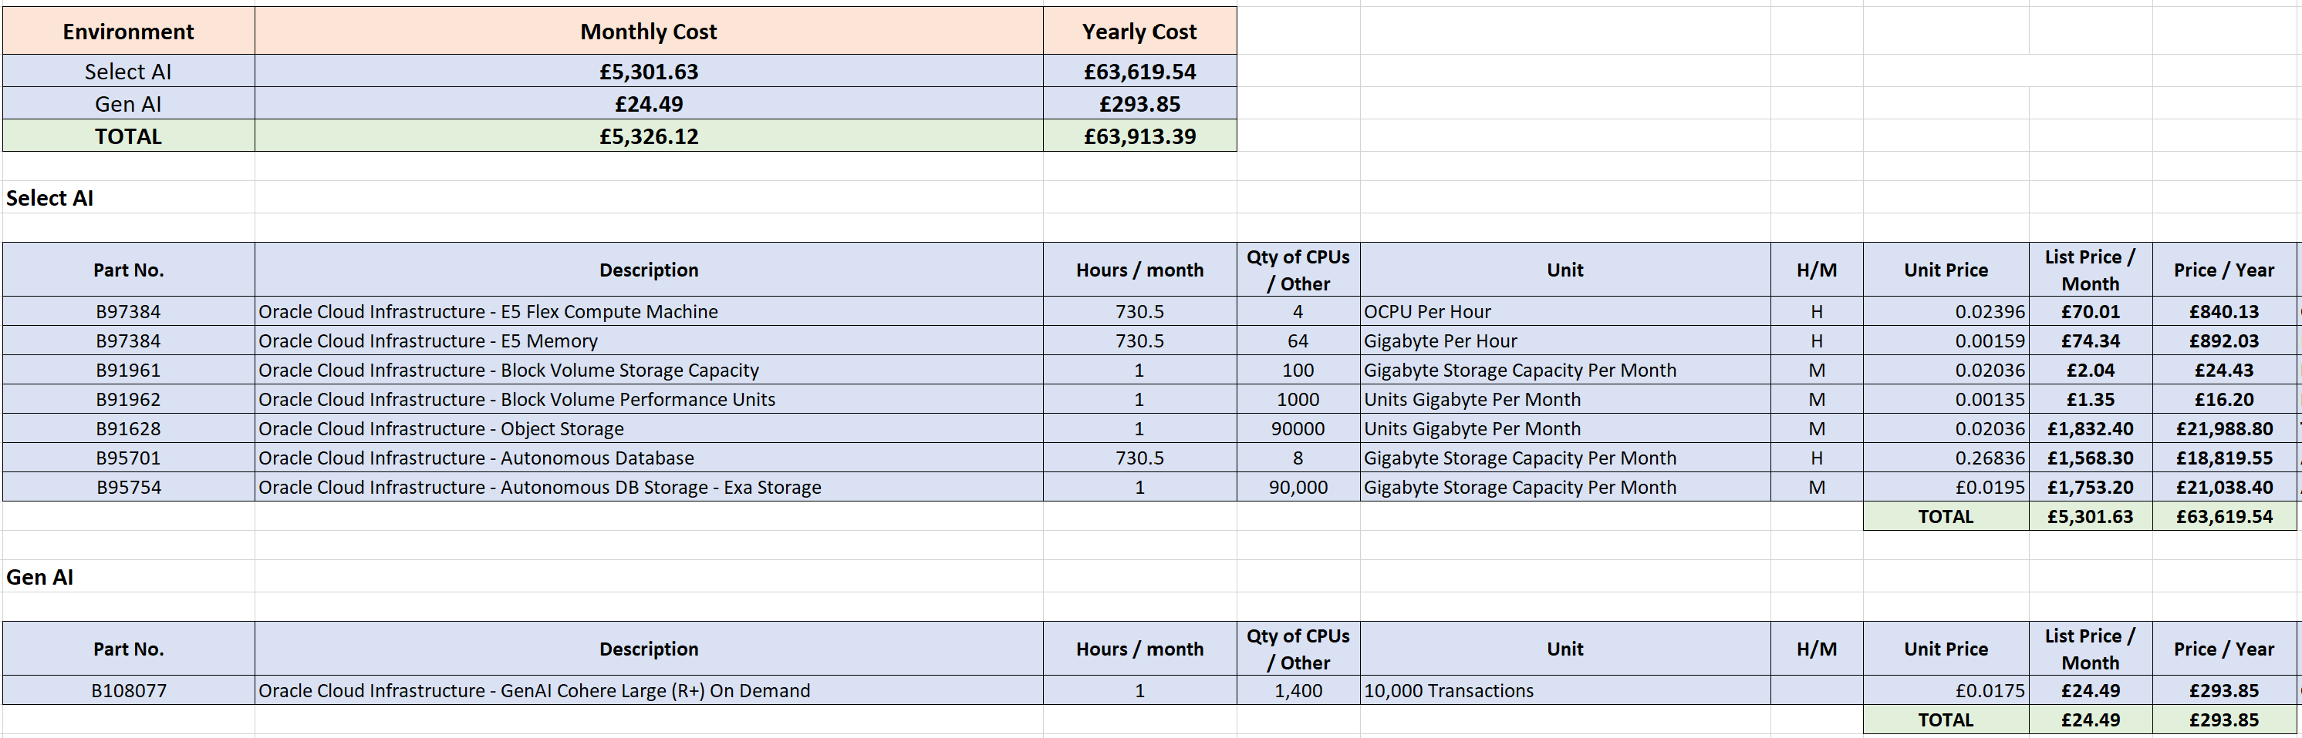

Assumptions
  - This is assumed that Analysts and Agents will use private network connection established between Vodafone and OCI Tenancy
  - All the users will use Apex as their main portal tool as a UI to ask questions
  - In the new BOM, due to storage size ECPU count is increased

3. Solution Components

3.1 Autonomous Database Select AI
Autonomous Database Select AI introduces an innovative capability: conversational interactions with your data. Unlike traditional natural language queries, conversations allow for dynamic, iterative data analysis. You can ask an initial question, review the results, and follow up with clarifying or additional queries, mimicking how we naturally communicate.
For example, an analyst for a movie streaming service might ask, “What are our total streams?” and follow up with, “Break that out by genre,” or “Add customer segment,” refining the inquiry with each step. Select AI, powered by an LLM (Large Language Model), interprets this conversational flow and automatically generates the necessary SQL. This seamless, intuitive interaction simplifies data exploration and empowers users to extract deeper insights with ease.

3.2 Generative ai and LLM Models
Generative AI, a fully managed Oracle Cloud Infrastructure (OCI) service, offers advanced, customizable large language models (LLMs) such as Meta LLaMA and Cohere Command R+, enabling a wide range of applications like conversational AI, text generation, summarization, and embedding creation. For Vodafone, these models bring transformative capabilities to enhance operations and customer interactions.
Meta LLaMA for Vodafone:
- Contextual Understanding: Ideal for automating repetitive tasks like report generation, summarizing complex documents, and crafting customer communications with high contextual accuracy.
- Fine-Tuning for Telecom Needs: Can be customized to Vodafone’s data for generating insights, improving service delivery, and creating telecom-specific solutions.
- Cost-Efficient Scalability: Optimized for large datasets, it offers efficient and scalable AI adoption.
Cohere for Vodafone:
- Enterprise-Grade NLP: Excels in building AI-powered assistants, automating customer support, and generating content tailored for Vodafone's internal and external needs.
- Security and Compliance: Designed with enterprise-grade security, ensuring robust data privacy—critical for the telecom sector.
- Customizable and Multilingual: Supports custom model development and multiple languages, making it ideal for global operations and a diverse customer base.

3.3 Low Code Apex UI
Oracle APEX (Application Express) is a powerful low-code development platform designed to create modern, responsive, and user-friendly applications with minimal effort. For Vodafone, Oracle APEX serves as the ideal front-end solution for building an intuitive interface that allows testing agents and other users to interact seamlessly with the AI-powered backend.
Key benefits of Oracle APEX for Vodafone include:
- Rapid Development: APEX enables quick and efficient application development with its low-code framework, reducing time-to-market for new solutions.
- User-Friendly Interface: The platform delivers a clean, responsive UI that simplifies data access, ensuring ease of use for testing agents handling thousands of scenarios.
- Integration Capabilities: Oracle APEX integrates seamlessly with Oracle databases and AI solutions, ensuring smooth interactions between the front-end interface and the backend systems.
- Customizable and Scalable: The platform supports extensive customization to meet Vodafone’s unique needs and can easily scale as operations grow.
- Built-In Security: With enterprise-grade security features, APEX ensures that applications remain compliant and protect sensitive data.

4. High level Architecture
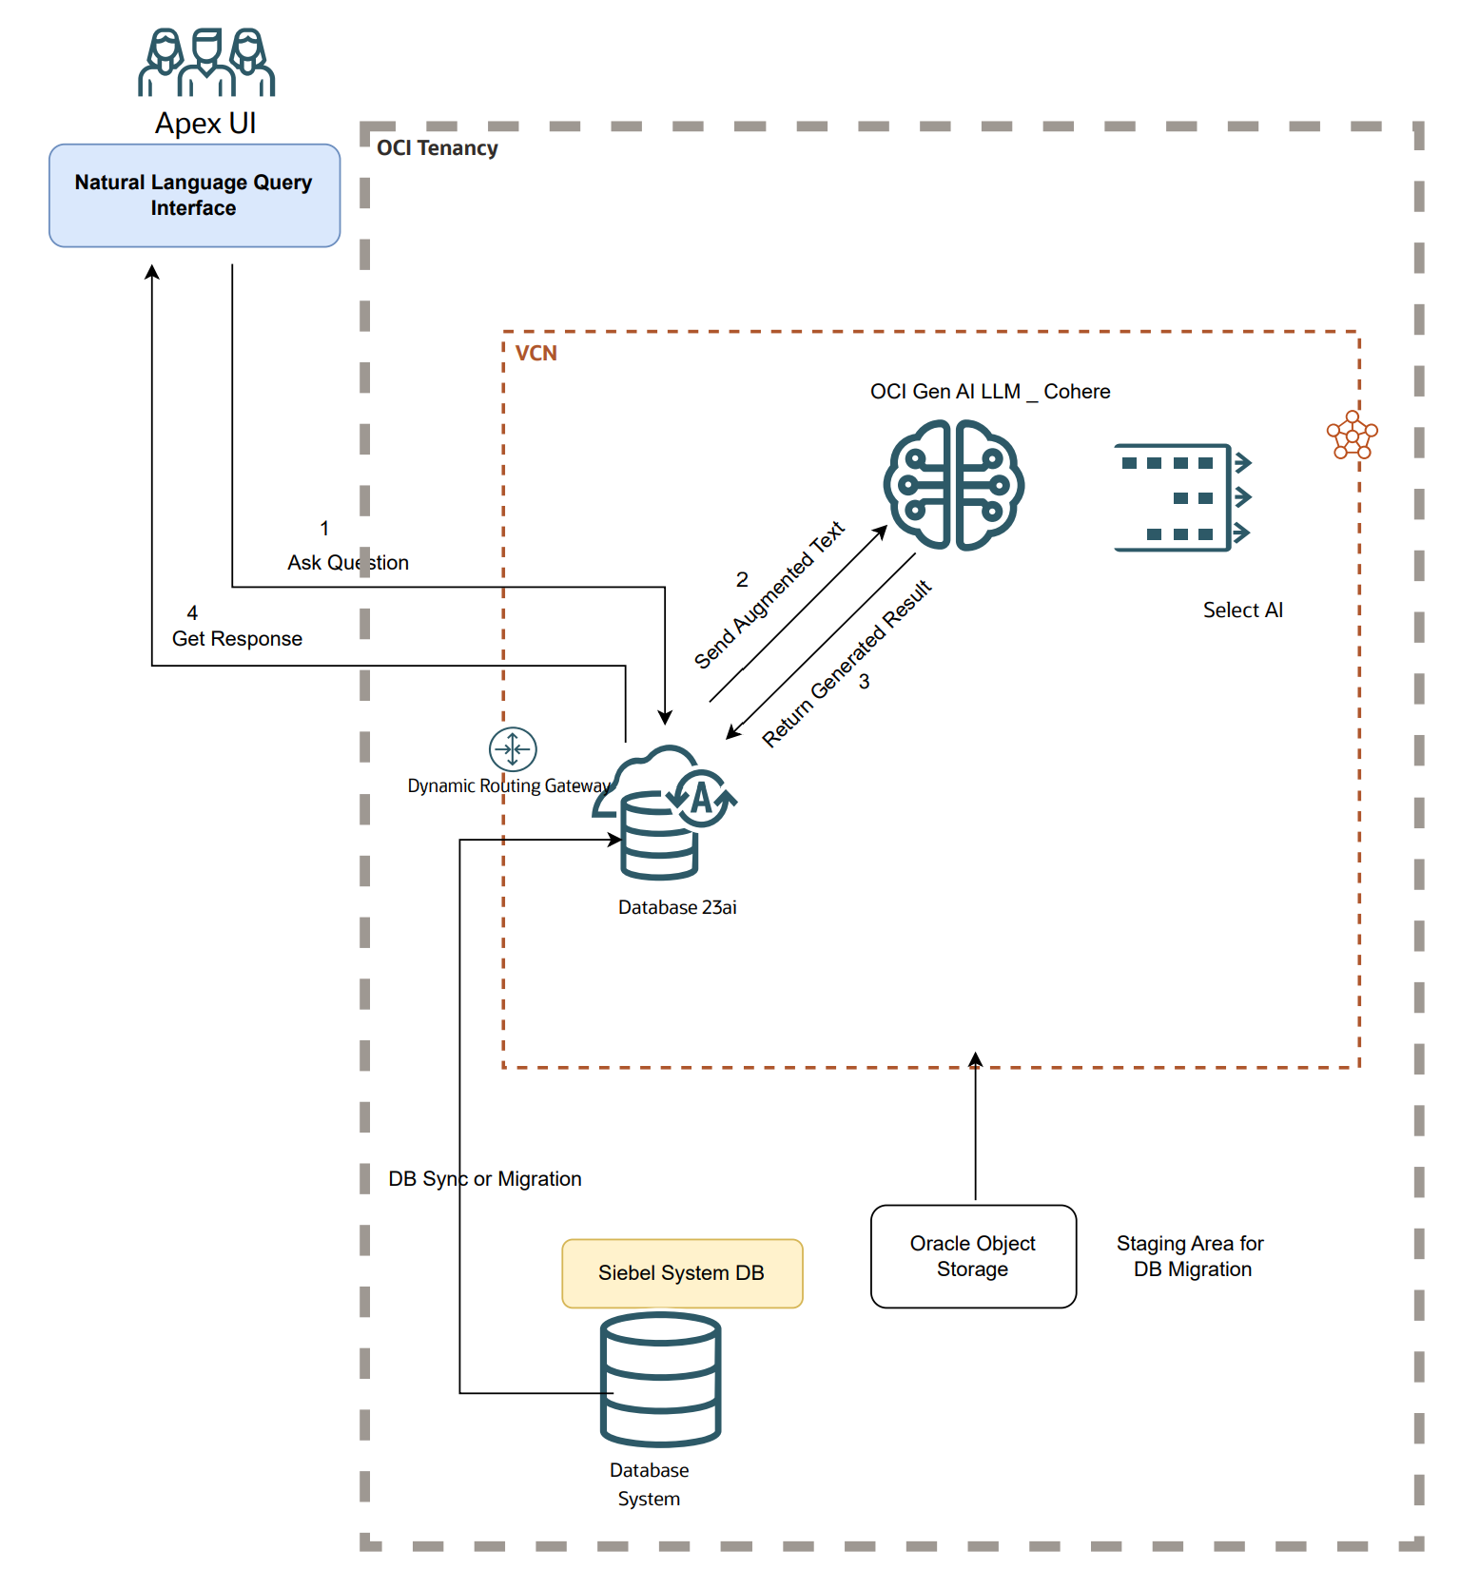

5. Conclusion

The integration of Generative AI through Oracle Cloud Infrastructure provides Vodafone with an unparalleled opportunity to revolutionize its operations. By leveraging advanced LLMs like Meta LLaMA and Cohere, Vodafone can automate repetitive tasks, streamline workflows, and enhance customer interactions with context-aware, scalable, and secure AI solutions.
These state-of-the-art models, tailored to Vodafone’s specific telecom needs, ensure optimal efficiency, multilingual capabilities, and enterprise-grade security, aligning with the organization’s strategic goals of innovation and operational excellence. This transformative solution positions Vodafone to lead in a competitive landscape, delivering exceptional value to its customers while achieving significant cost savings and productivity gains.

6. References
- https://apex.oracle.com/en/
- https://www.oracle.com/uk/autonomous-database/select-ai/
- https://www.oracle.com/uk/artificial-intelligence/generative-ai/generative-ai-service/

